
Sara Gerke
Assistant Professor of Law
Penn State Dickinson Law
234
Lewis Katz Hall
150
S. College St.
Carlisle, PA 17013
sgerke@psu.edu
U.S. and EU Tort Liability in
Healthcare’s Black-Box AI Era
Indiana Law Review Symposium
February 9, 2024
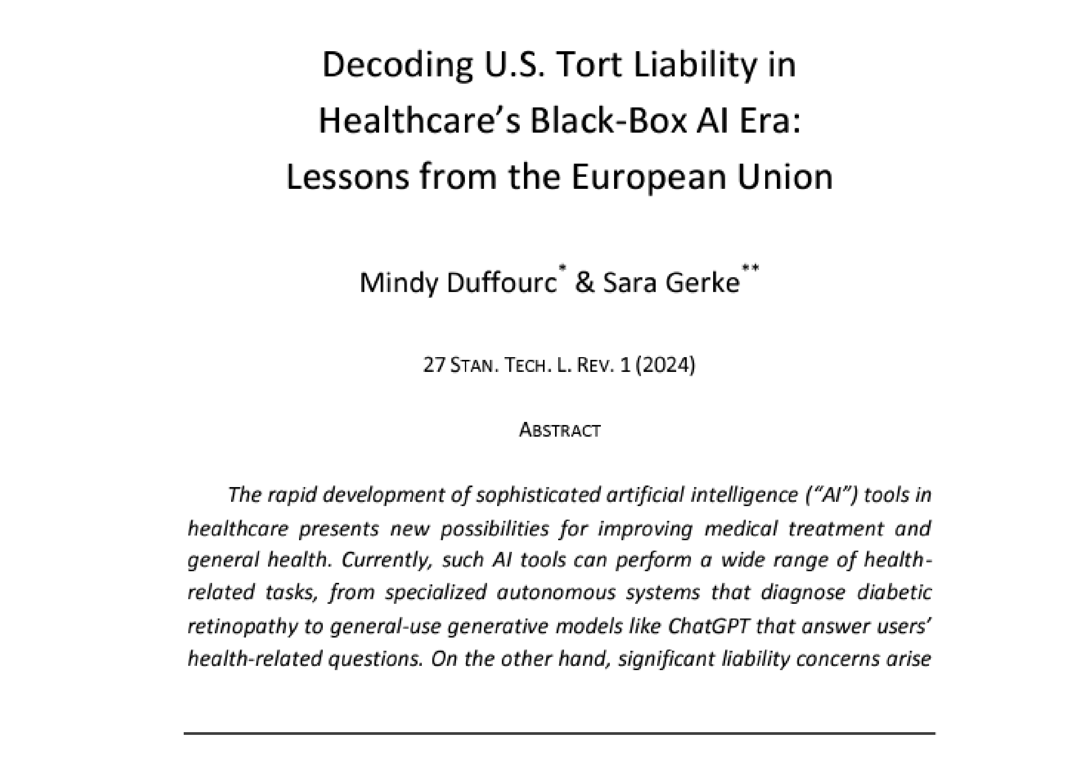
https://law.stanford.edu/publications/decoding-u-s-tort-liability-in-healthcares-black-box-ai-era-lessons-from-the-europeanunion/


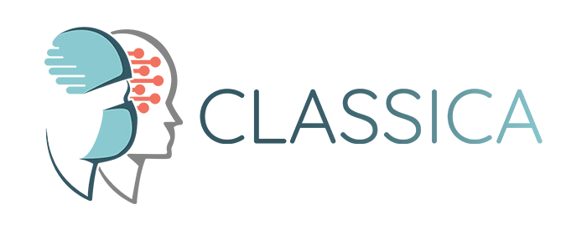
3
https://classicaproject.eu/
Funded by the European Union. Views and opinions
expressed are however those of the author(s) only and
do not necessarily reflect those of the European Union or
the Health and Digital Executive Agency. Neither the
European Union nor the granting authority can be held
responsible for them.
@classicaproject

Outline

o Crucial Features of Black-Box AI o Comparative Analysis of the EU and U.S. Liability Frameworks

o Lessons Learned From the EU’s Approach to Black-Box AI Liability

1.
Black-Box AI
This image was created with the assistance of DALL E.

Black-Box AI
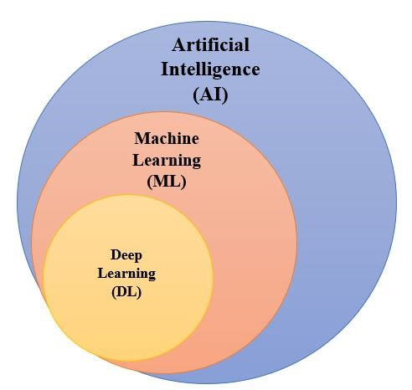
AI and Relevant Subsets
Figure (AI and Relevant Subsets) adapted from Sara Gerke, “Nutrition Facts Labels” for Artificial Intelligence/Machine Learning-Based Medical Devices—The Urgent Need for Labeling Standards, 91 GEO. WASH. L. REV. 79, 88 (2023); Photo credit (black box): © olga_milagros - stock.adobe.com
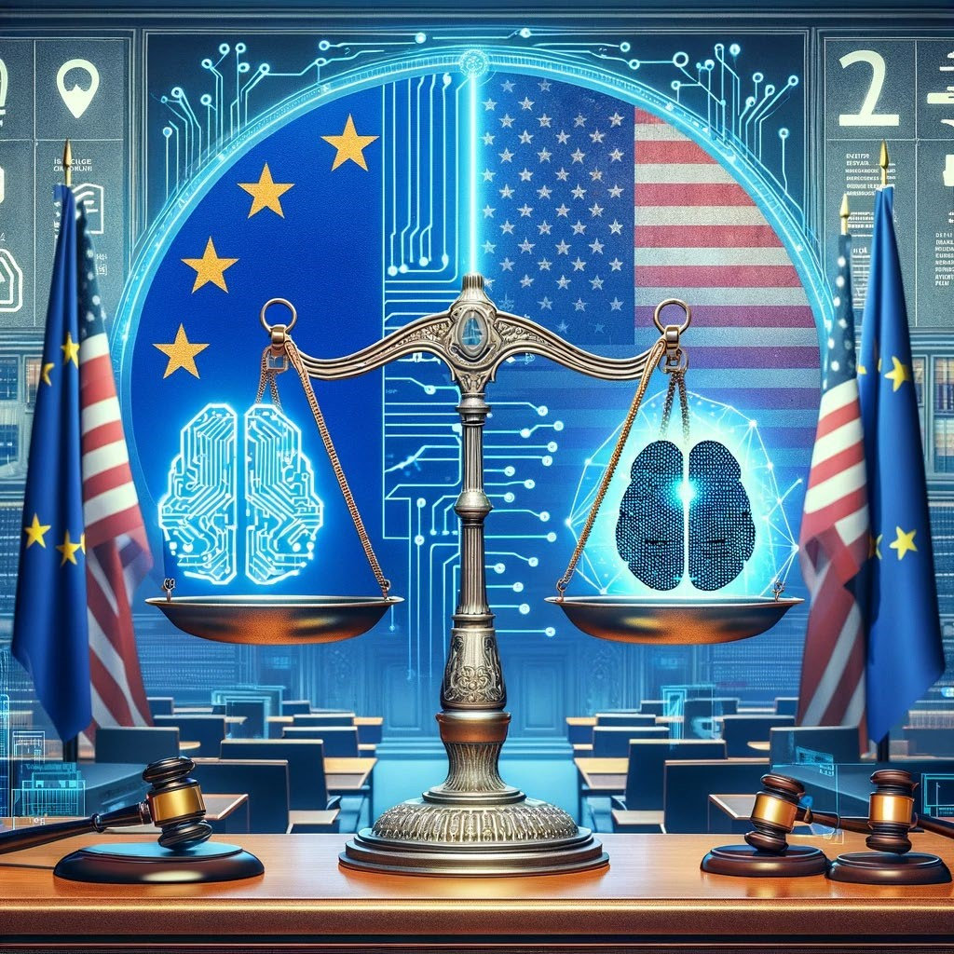
2.
EU and U.S. Liability
Frameworks
This image was created with the assistance of DALL E.
Tort Liability for Black-Box AI Manufacturers in the United States and European Union
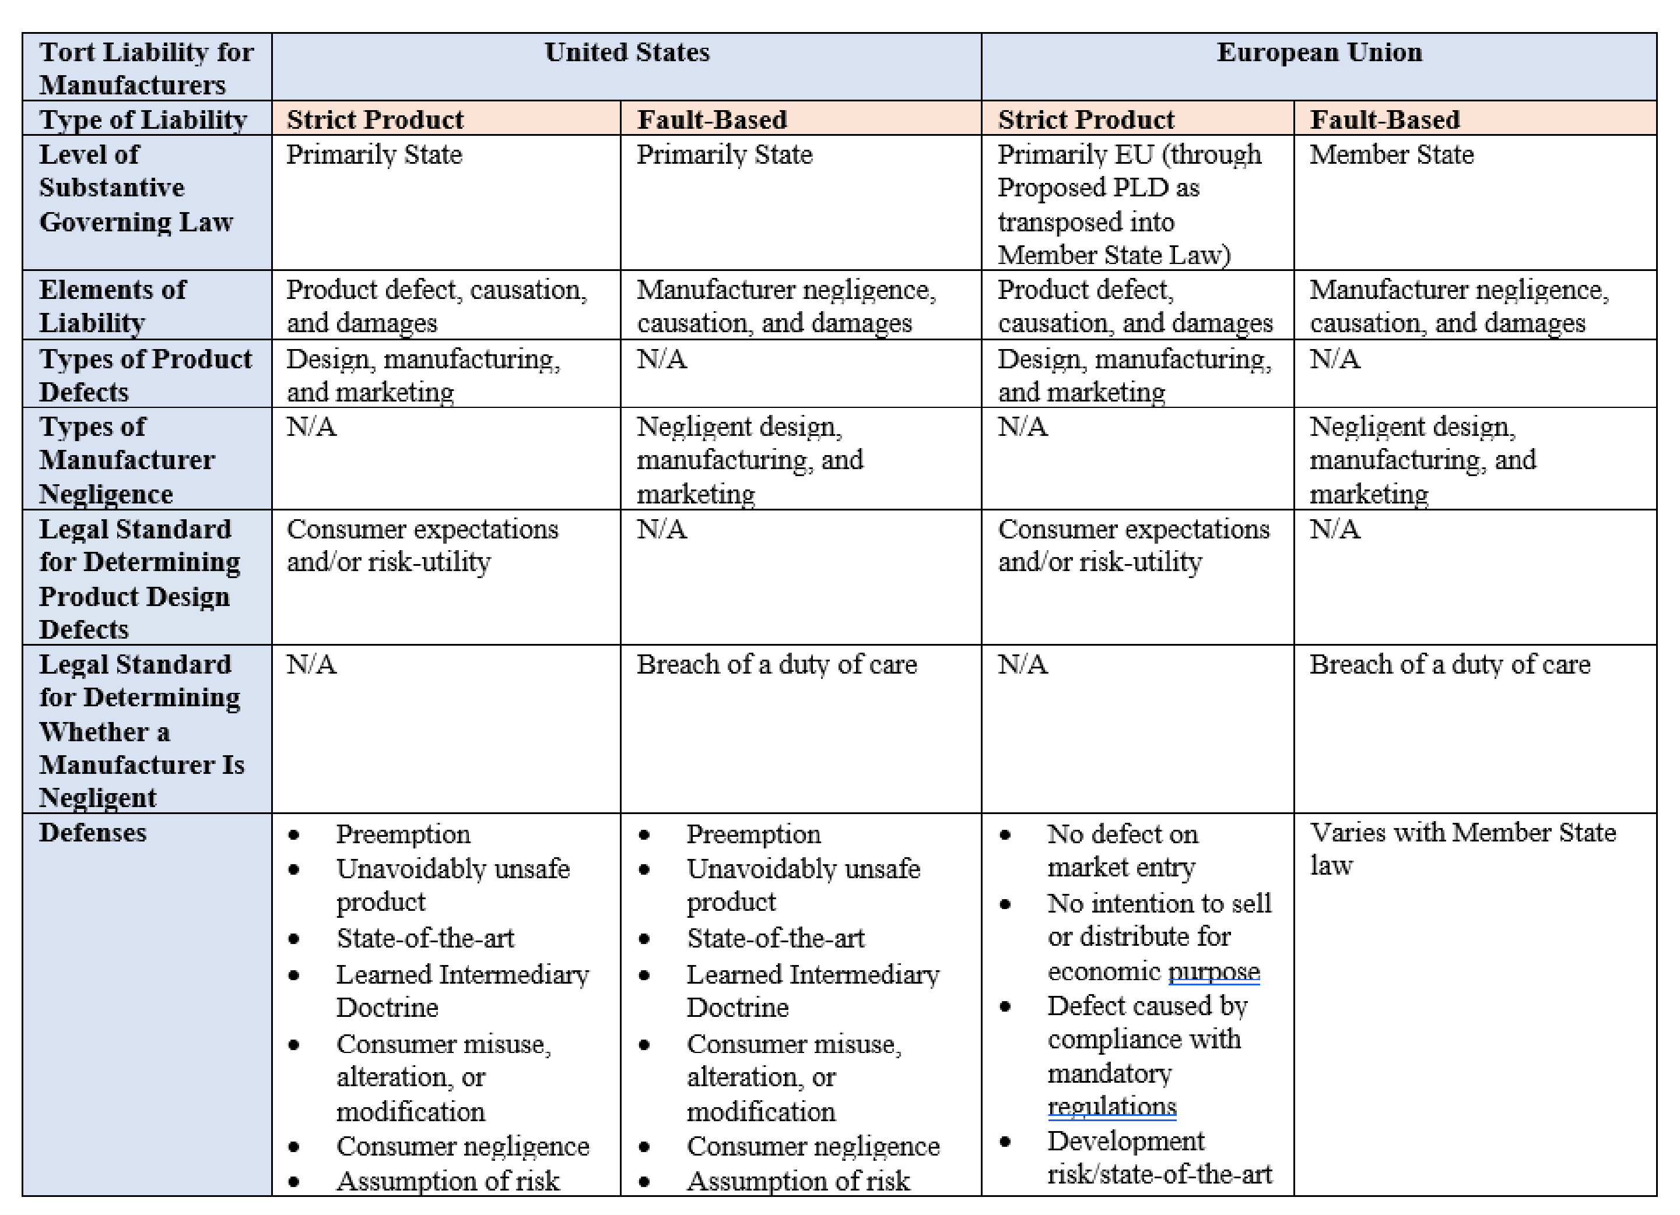
Medical Liability for Individual and Organizational Healthcare Providers Using
 | Black-Box AI | in the United States and European Union

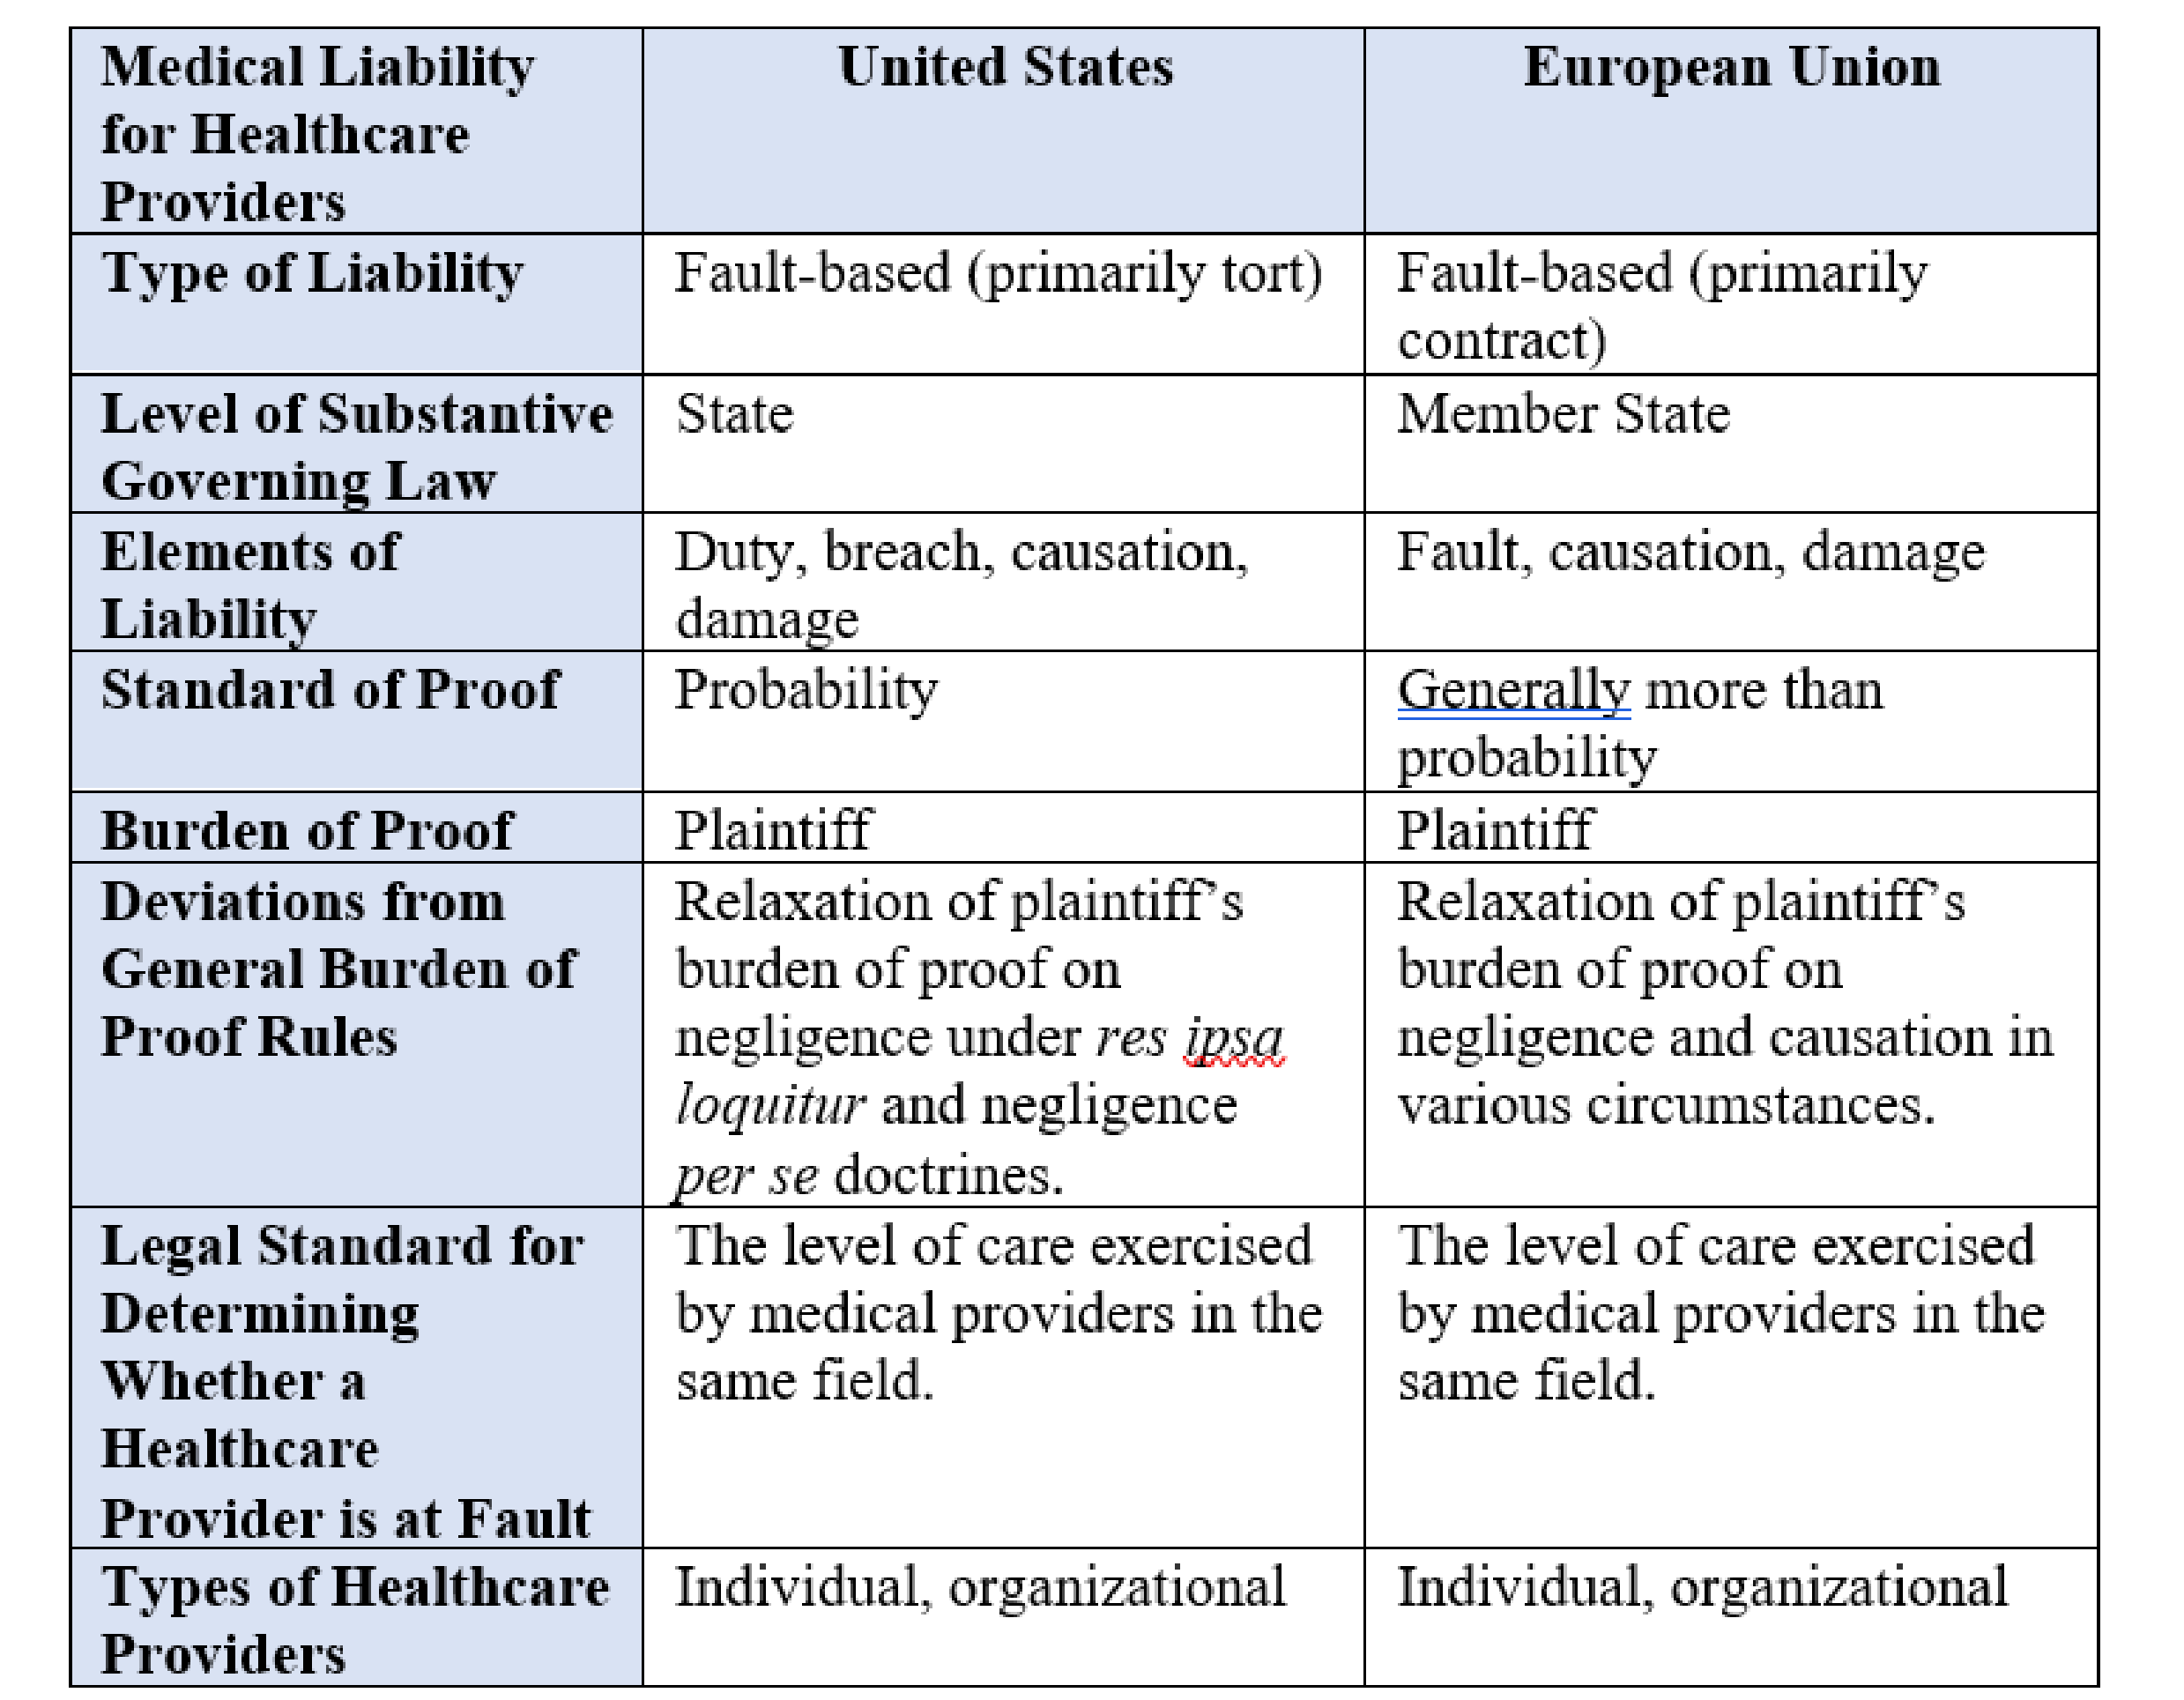

Common Challenges to Liability in the U.S. and EU


Both jurisdictions In both
AI-driven
technologies do
not always
operate like
traditional
products
,
rendering the
existing product
liability rules
inadequate
for
certain cases
involving AI-driven
medical
“products.”
In both
jurisdictions,
patients might
struggle to
gather evidence
and meet the
burden of proof
in some cases
where
AI causes
injuries.


are confronted with jurisdictions, it the immense task might pose a of adjusting their challenge for legal systems to plaintiffs to
accommodate the establish a
new demands that connection

accompany the between injuries
rapid
advancement and caused by AI

integration of AI and the fault of a
technology party that can be
across various held legally
sectors of responsible under society, including the current liability healthcare. framework.
The images were created with the assistance of DALL E.

Recent Developments in the EU
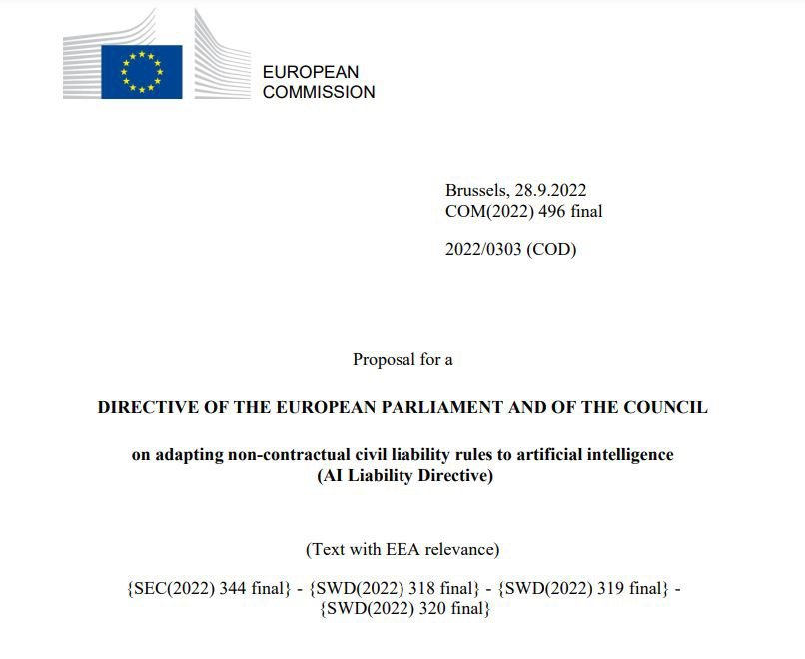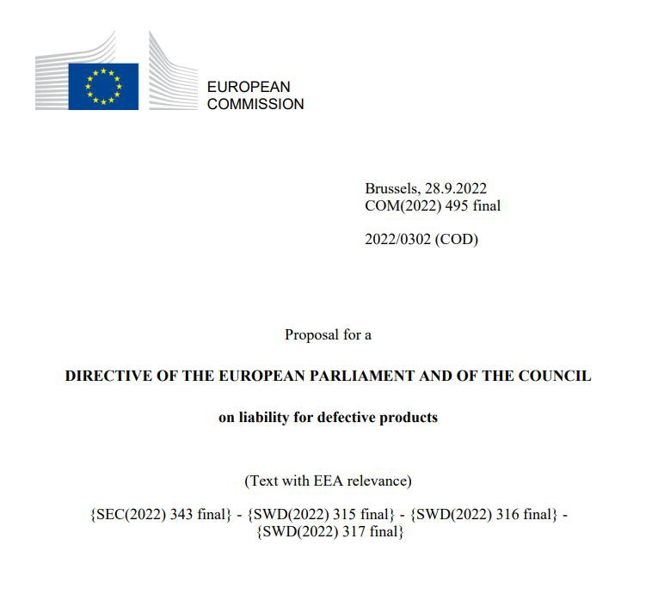
https://single-market-economy.ec.europa.eu/system/files/2022-09/COM_2022_495_1_EN_ACT_part1_v6.pdf https://commission.europa.eu/system/files/2022-09/1_1_197605_prop_dir_ai_en.pdf

3.
Lessons Learned
This image was created with the assistance of DALL E.

Lessons Learned From the EU’s Approach to Black-Box AI Liability
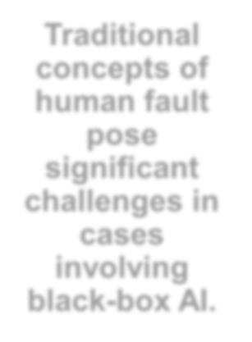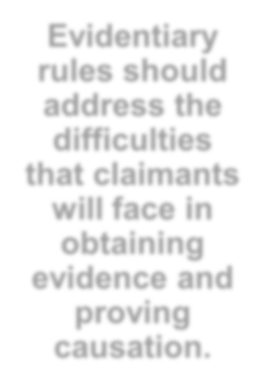
A broad
approach to
AI liability
fails to
provide
solutions to
some
challenges
posed by
black-box
AI
in healthcare.
Traditional
concepts of
human fault
pose
significant
challenges in
cases
involving
black-box AI.
Product
liability
frameworks
must
consider the
unique
features of
black-box AI.
Evidentiary
rules should
address the
difficulties
that claimants
will face in
obtaining
evidence and
proving
causation.
The images were created with the assistance of DALL E.


sgerke@psu.edu
@
gerke_sara
14
Photo credit: © Courtney D. Verdelli –
Penn State Dickinson Law

