STATE OF INDIANA ) IN THE MARION COURT
)
COUNTY OF MARION )
) CAUSE NO.:

SANDRA BARNES, )
Plaintiff, )
v. )
)
INDIANAPOLIS HOUSING AGENCY, LUGAR LP, )
BRADLEY COMPANY, LLC )
Defendants. )

COMPLAINT FOR BREACH OF LEASE, BREACH OF WARRANTY OF HABITABILITY, BREACH OF COVENANT FOR QUIET ENJOYMENT, AND BREACH OF SETTLEMENT AGREEMENT

COMES NOW Plaintiff Sandra Barnes, by counsel, and files her Complaint for Breach of Lease, Breach of Warranty of Habitability, Breach of Covenant for Quiet Enjoyment, and Breach of Settlement Agreement. In support of her claims, Ms. Barnes states:
Introduction
- The residents of Lugar Tower in downtown Indianapolis are virtually all seniors and/or persons living with disabilities. For years, they have been victimized by their landlords’ neglect, especially the neglect of the Indianapolis Housing Agency, that has forced them to live in filthy conditions—including months of unremedied human feces and urine in the stairwells.
- The neglect of Lugar Tower’s landlords also forced the residents to try to survive in a perpetually violent environment that included multiple shootings and stabbings and a refusal by their landlords to make their apartment doors safe from repeated break-ins. According to publicly-available data provided by the Indianapolis Metropolitan Police Department, there were 525 dispatches of the Indianapolis Metropolitan Police Department to the 900 block of Fort Wayne Avenue, the location of Lugar Tower, during the first nine (9) months of 2023. Those dispatches include multiple reports of assaults, burglaries-in-progress, and dead bodies being found.
- On April 26, 2023, multiple residents of Lugar Tower, including Plaintiff Sandra Barnes, filed a lawsuit in Marion Superior Court against their landlords over these conditions, Williams et al. vs. Lugar LP et al., Cause Number 49D11-2304-PL-016917.
- After the lawsuit was filed, Lugar Tower conditions improved, including the addition of 24-hour security on the premises.
- Due to the improvement in the conditions, and the promises their landlords made in an enforceable Settlement Agreement to keep in compliance with the law and the terms of the Assurance of Voluntary Compliance the Attorney General reached with the Indianapolis Housing Agency under Cause Number 49D12-2308-MI-031784, promises which included commitments to ensure safe conditions and a reasonable security presence, the Lugar Tower residents agreed to settle their claims under Williams et al. vs. Lugar LP et al., Cause Number 49D11-2304-PL-016917.
- On November 2, 2023, Marion Superior Judge John F. Hanley granted the parties’ mutual request to dismiss the claims under Williams et al. vs. Lugar LP et al., Cause Number 49D11-2304-PL-016917.
- On November 3, 2023, the very day after Judge Hanley signed the dismissal order, Lugar Tower residents including Ms. Barnes learned that the Defendants intended to pull out weekday daytime security from Lugar Tower. Since the following Monday, November 6, daytime security has not been in place at Lugar Tower.
- Ms. Barnes by counsel notified that same day of November 6th counsel for Defendants and the Office of the Attorney General that the residents were being put in danger by the Defendants’ breach of their Agreement, the Assurance of Voluntary Compliance, and violating applicable law. As of this filing, the weekday daytime security presence has not been restored.
- Defendants, by failing to remedy a serious safety issue within a reasonable time of receiving notice of the same, violated Ms. Barnes’ rights and the rights of other Lugar Tower residents under the Indiana Landlord-Tenant Relations statute, Indiana Code § 32-31-8-5, the terms of her lease, her right to quiet enjoyment of the premises, and her rights under the Settlement Agreement fully executed by her and Lugar LP and Bradley Company LLC on October 26th, 2023. A verified motion for Temporary Restraining Order is being filed along with this Complaint, asking for an immediate Court order directing Defendants to restore daytime security.
Parties
- Sandra Barnes is a resident of the property located at 901 Fort Wayne Avenue, Apartment 616, Indianapolis, Indiana 46202, known as Richard Lugar Tower (“Lugar Tower”).
- Lugar Tower is a building in downtown Indianapolis with approximately 250 one-bedroom apartments located on 17 floors.
- Defendant Indianapolis Housing Agency is an administrator of Lugar Tower under the terms of a Rental Assistance Demonstration (RAD) agreement.
- Defendant Lugar LP is the owner of Lugar Tower.
- Defendant Bradley Company LLC provides property management services for Lugar Tower.
- On or about 2015, Ms. Barnes entered into a one-year lease with Indianapolis Housing Agency to rent an apartment at Lugar Tower. Like other public housing leases, it was automatically renewed unless there is good cause for non-renewal. Not all of the lease documents are in Ms. Barnes’ possession, but copies of the lease documents in Ms. Barnes’ possession are attached to this Complaint, pursuant to Indiana Trial Rule 9.2, as Exhibit A.
- Attached to this Complaint, as Exhibit B, is a lease that, upon information and belief, Ms. Barnes believes to be the model that the Indianapolis Housing Agency uses with its tenants.
Factual Allegations
- On or about November 6, 2023, Defendants withdrew the daytime security presence from Lugar Tower.
- At the time that they withdrew daytime security presence from Lugar Tower, Defendants were aware of the significant safety risks to Ms. Barnes and other residents caused by withdrawing daytime security from the building.
- According to publicly-available data provided by the Indianapolis Metropolitan Police Department, there were 525 dispatches of the Indianapolis Metropolitan Police Department to the 900 block of Fort Wayne Avenue, the location of Lugar Tower, during the first nine (9) months of 2023—despite professional security being in place 24-hours-per-day since April of 2023. The IMPD reports downloaded from CityProtect.com are attached to this Complaint as an Exhibit C.
- Those dispatches include daytime Monday-Friday hours reports of assaults, burglaries-in-progress, and dead bodies being found.
- Ms. Barnes and other residents have witnessed daytime security crises in and around Lugar Tower, especially non-residents being allowed into the building by side doors, which happens regularly when professional security is not present. Ms. Barnes’ experience is that the people being let in by the side doors pose a substantial risk to my safety and the safety of other residents.
- On November 6, 2023, Ms. Barnes by counsel advised Defendants of the significant safety risks posed to Ms. Barnes and other residents caused by withdrawing daytime security from the building.
- On November 6, 2023, Ms. Barnes by counsel advised the Office of the Attorney General of the significant safety risks posed to Ms. Barnes and other residents caused by withdrawing daytime security from the building, and the Defendant Indianapolis Housing Agency’s breach of the ssurance of Voluntary Compliance the Attorney General reached with the Indianapolis Housing Agency under Cause Number 49D12-2308-MI-031784.
- As of this filing, Defendants have not restored daytime security to Lugar Tower and have confirmed they have no intention of doing so.
- On November 13, 2023, Ms. Barnes and fourteen (14) other Lugar Tower residents filed Consumer Complaints with the Office of the Indiana Attorney General stating that the withdrawal of security violates their rights, including their rights under the Assurance of Voluntary Compliance the Attorney General reached with the Indianapolis Housing Agency under Cause Number 49D12-2308-MI-031784. Those Consumer Complaints are attached as Exhibit D.
- The Defendants’ withdrawal of security during daytime hours violates the Defendants’ obligations to provide Ms. Barnes and other residents with safe premises in which to live.
- Pursuant to Indiana Trial Rule 65 (B) and Indiana Code § 32-31-8-6(d), Ms. Barnes is filing along with this Complaint a Verified Motion for Preliminary Injunction, citing her fear that the Defendants’ withdrawal of security during daytime hours will cause her immediate and irreparable injury, loss, or damage before the Defendants can be heard in opposition.
Breach of Settlement Agreement
- The full terms of the Settlement Agreement executed by Ms. Barnes, Lugar Tower resident Oscar Estrada, Lugar LP, and Bradley Company LLC on October 26th, 2023 are confidential, so Ms. Barnes requests permission to submit the Settlement Agreement to this Court under seal.
- Despite the full terms of the Settlement Agreement being confidential, the Agreement does allow the parties to disclose that the Agreement “ensures that the Property will be maintained according to Indiana, Federal, and local law, and according to the terms of the Assurance of Voluntary Compliance under Cause Number 49D12-2308-MI-031784.”
- The terms of the Assurance of Voluntary Compliance under Cause Number 49D12-2308-MI-031784 include a promise in Paragraph 26 that Defendant Indianapolis Housing Agency “will continue to ensure there is reasonable security presence at the Lugar Tower Apartments (until August 8, 2025).”
- In the days leading to the Defendants removing daytime security from Lugar Tower, the following events occurred:
  - Pursuant to the terms of the Settlement Agreement, Ms. Barnes’ and another Lugar Tower resident, Oscar Estrada, and Defendants Lugar LP and Bradley Company LLC submitted a joint motion to dismiss all claims under Cause Number 49D11-2304-PL-016917, including Ms. Barnes’ claims for breach of lease, warranty of habitability, and covenant for quiet enjoyment. On November 2, 2023, Marion Superior Judge John F. Hanley ordered the dismissal.
  - The very next day, November 3rd, Ms. Barnes heard from other residents that the Defendants planned to remove professional security from the building during daytime hours Monday-Friday. That security had been in place since shortly after Ms. Barnes’ lawsuit in 49D11-2304-PL-016917 was filed in April, 2023.
  - On the morning of Monday, November 6, Ms. Barnes came down to the lobby of Lugar Tower and found there was no security presence. She took this photograph of the front desk area, which was empty:
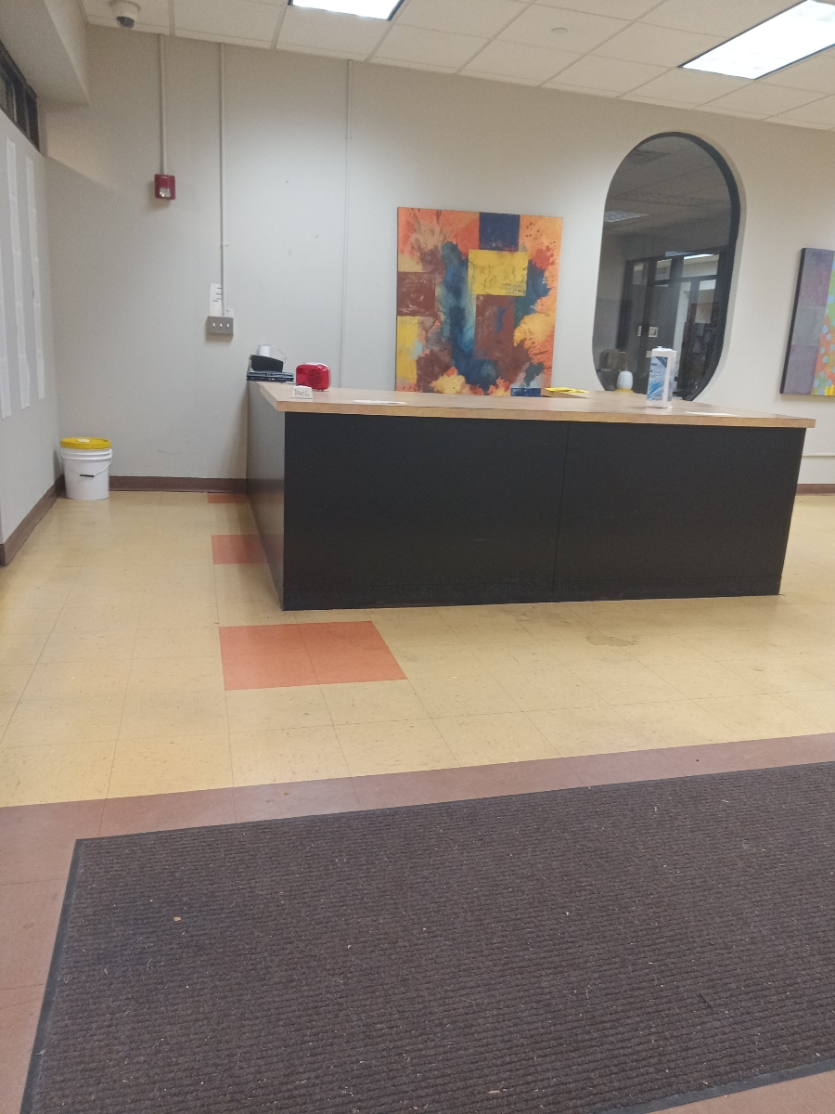
  - Later that day, Defendants confirmed to counsel for Ms. Barnes that they were no longer going to provide her and other residents with professional security from 8AM to 4PM on Monday-Friday.
  - On multiple occasions since November 6th, Ms. Barnes has observed the front desk without any personnel present.
- The Defendants’ actions constitute a breach, unremedied after notice, of the Settlement Agreement between Defendants Lugar LP and Bradley Company and Ms. Barnes.

Count Two—Breach of Covenant of Quiet Enjoyment
- Indiana law recognizes an implied covenant of quiet enjoyment of the premises is provided by landlords to tenants.
- As a result of their failure to remedy the issues described in Paragraphs 17 through 27 above within a reasonable time of receiving notice, Defendants violated Ms. Barnes’ right to quiet enjoyment of the premises.

Count Three—Breach of Implied Warranty of Habitability
- Chapter 8 of the Indiana Landlord-Tenants Relations Statute, Indiana Code § 32-31-8-5 requires the Defendants to deliver the rental premises to a tenant in compliance with the rental agreement, and in a safe, clean, and habitable condition.
- As a result of their failure to remedy the issues described in Paragraphs 17 through 27 above within a reasonable time of receiving notice, Defendants violated Ms. Barnes’ right under Indiana Code § 32-31-8-5.
- Indiana Code § 32-31-8-6 (d) includes injunctive relief as an available remedy for violations of this statute.
Count Four—Breach of Lease Agreement
- As noted above, Ms. Williams does not have a copy of her current Lease Agreement with the Defendants, but pursuant to Indiana Trial Rule 9.2 has provided with this filing the Lease-related documents in her possession.
- Upon information and belief, Ms. Barnes submits that her lease agreements obligate the Defendants to maintain the common areas and facilities in safe condition. As noted above, a sample of the Indianapolis Housing Agency’s Model Lease is attached to this filing. Those landlord obligations are contained in Paragraph 10 of the Model Lease.
- As a result of their failure to remedy the issues described in Paragraphs 17 through 27 above within a reasonable time of receiving notice, Defendants violated Ms. Barnes’ rights under the parties’ Lease Agreement.
Jury Trial Request
Ms. Barnes requests that this matter be tried to a jury.
Prayer for Relief
WHEREFORE, Ms. Barnes respectfully requests the Court:
  - As outlined in Ms. Barnes’ Verified Motion for Temporary Restraining Order, exercise its authority under Indiana Code § 32-31-8-6 (d) and Indiana Trial Rule 65(B) and issue a Temporary Restraining Order requiring the Defendants to immediately reinstate daytime security at Lugar Tower;
  - Exercise its authority under Indiana Code § 32-31-8-6 (d) and order the Defendants to permanently remedy the safety and habitability issues at Lugar Tower and maintain continuing jurisdiction to monitor compliance with its orders;
  - Award Ms. Barnes damages for breach of her lease, breach of the implied warranty of habitability, breach of the covenant of quiet enjoyment, and breach of her Settlement Agreement;
  - Award Ms. Barnes court costs and attorney’s fees pursuant to Indiana Code § 32-31-8-6 and her Settlement Agreement; and
  - Grant all other just and proper relief.
Respectfully Submitted,

/s/ Jodi M. Velasco_________
Jodi M. Velasco, Attorney ID# 37149-49
INDIANA LEGAL SERVICES, INC.
1200 Madison Ave, Suite 300
Indianapolis, Indiana 46225
Telephone: (317) 631-9410, x 12349
Facsimile: (317) 631-9775
Email: jodi.velasco@ilsi.net

/s/ Fran Quigley
Fran Quigley, Attorney # 13877-49
Health and Human Rights Clinic
Indiana University McKinney School of Law
530 W. New York Street
Indianapolis, IN 46202
(317) 274-1911
FAX (317) 274-8901
Quigley2@iupui.edu

CERTIFICATE OF SERVICE
I hereby certify that this Motion was provided to Defendants via service to their counsel, Libby Moyer, Ice Miller LLP, through the Indiana EFiling System (IEFS) and/or email, per agreement with counsel.

___/s/ Fran Quigley_______________
Fran Quigley, Attorney # 13877-49
Attorney for Plaintiff

